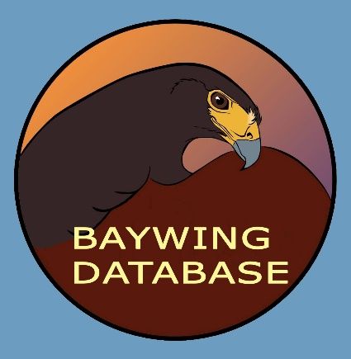
The Harris’s Hawk
Pedigree and Hunting Performance Registry
http://baywingdatabase.com
Curator: Jennifer Coulson
Email: jennifercoulson@baywingdatabase.com
Please register your hawk in the Baywing Database and provide its pedigree data. The website provides several ways of submitting data or you can fill out this form and mail it or scan and email it to Jennifer. Please submit information on your hawk even if it is incomplete. If you are unsure of something, leave the field blank. General comments can include former owners, previous band numbers, name of hawk’s mate if bred, etc.

Pedigree Data:
Owner: ____________________________________
Hawk’s name: _______________________________ Band number: ___________________
Sex (M/F): _________________
Hatch year (4 digits):_____________________
Father's name: _____________________________
Father's band number: ___________________________
Mother's name: ___________________________
Mother's band number: ___________________________
Captive-bred (CB) or Wild-caught (WC) : ___________________________
Breeder's name: ________________________________________________
Country of origin if wild-caught: : ___________________________
State of origin if wild-caught Locality of origin if wild-caught: ___________________________
Subspecies (harrisi, unicinctus, or a cross) : ___________________________
General comments: _____________________________________________________________
______________________________________________________________________________

Mail to: Jennifer Coulson, 64340 Fogg Lane, Pearl River, LA 70452

