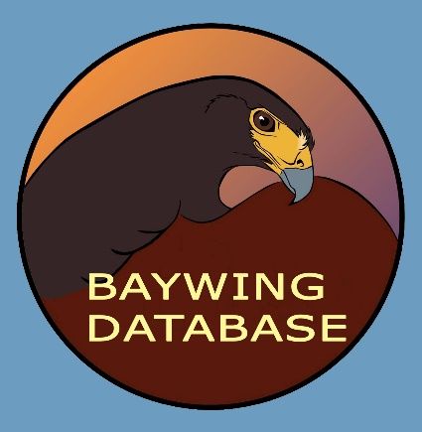
The Harris’s Hawk
Pedigree and Hunting Performance Registry
http://baywingdatabase.com
Curator: Jennifer Coulson
Email: jennifercoulson@baywingdatabase.com
Your hawk is registered in the Baywing Database. Please email Jennifer with your hawk’s name. Please also report the hawk’s kills and rate its field performance at the end of each field season. The website provides several ways of submitting data or you can fill out this form and mail it or scan and email it to Jennifer. Please also report if you transfer the hawk and to whom, or if the hawk dies, when and the cause of death.
Hunting Performance Data:
Owner: ____________________________________
Hawk’s name: _______________________________ Band number: ___________________
Flying weight in grams (1 ounce = 28.3 grams): _____________
Seasons hunted (fractional seasons O.K.): ___________
Total number of Rabbits caught: ____________
Total number of Hares/Jackrabbits caught: ____________
Total number of Squirrels caught: ____________
Total number of Upland birds (quail, pheasants, etc.) caught: ____________
Total number of Waterfowl (ducks, geese, coots, moorhens, etc.) caught: ____________
Total number of Miscellaneous (crows, starlings, etc.) caught: ____________
Total kills over all seasons, number of Kills in the hawk's best season: ____________
Owner's name during the hawk's best season: ____________________________________
Instructions: For the following categories, rank the hawk from 1-5 with 1=worst and 5=best. Hawks should be judged relative to all other Harris' hawks you have flown or seen flown. Remember, even an average (score=3) Harris' hawk is a great hunting bird! Enter 'ND' (for not determined) if the hawk cannot be scored for a particular category (for instance, if it has never been flown with dogs or hunted in a group).
Overall rank (1=awful, 5=incredible): ____________
Group hawking (1=fights constantly, 5=never fights even when provoked): ____________
Hunts well with Dogs (1=attacks large dogs, 5=trustworthy around small dogs): ___________
Follows and maintains position in the field (1=lags constantly and/or sits low; 5=follows close and high): _______________
Flight Speed (1=loses ground to a running rabbit, 5=like a goshawk with brains): ___________
Footing (1=misses easy catches, 5=tractor beam): _____________
Persistence in pursuit (1=gives up easily, 5=never quits): ____________
Hunting comments (264 character limit): ____________________________________________________________________________
Mail to: Jennifer Coulson, 64340 Fogg Lane, Pearl River, LA 70452

